Ex.no:4b | EXPLORATORY DATA ANALYSIS (EDA) – DATA INSPECTION, FILTERING, STATISTICAL ANALYSIS AND CORRELATION

AIM

To perform data inspection, filtering, sorting, grouping, aggregation, descriptive statistical analysis, and correlation analysis on the California Housing Dataset using Pandas, and to visualize the analytical results using Matplotlib and Seaborn.

ALGORITHM
Algorithm 1: Dataset Inspection
- Import the California Housing Dataset.
- Display the first few records of the dataset.
- Check the dimensions of the dataset.
- Display the data types of the attributes.
- Generate a statistical summary of the numerical attributes.
Algorithm 2: Filtering Data
- Select the required attribute such as Median House Value or Median Income.
- Specify a suitable filtering condition.
- Apply the condition to the dataset.
- Display the filtered records.
Algorithm 3: Sorting Data
- Select the attribute to be sorted such as Median House Value.
- Apply the sort_values() function.
- Specify the sorting order.
- Display the sorted dataset.
Algorithm 4: Statistical Analysis
- Select the required numerical attribute such as Median House Value.
- Calculate the mean.
- Calculate the median.
- Calculate the mode.
- Calculate the standard deviation.
- Display the calculated statistical measures.

Algorithm 5: Grouping and Aggregation
- Select a categorical attribute such as Ocean Proximity.
- Apply the groupby() function.
- Select the required numerical attribute such as Median House Value.
- Calculate an aggregate measure such as mean.
- Display the grouped results.
Algorithm 6: Correlation Analysis
- Select the required numerical attributes such as Median Income, Total Rooms, Population, and Median House Value.
- Apply the corr() function.
- Generate the correlation matrix.
- Analyze the correlation coefficient between the selected attributes.
- Visualize the relationship using appropriate graphs.

CODE
# ============================================================
# EX NO: 4b
# EXPLORATORY DATA ANALYSIS
# DATA INSPECTION, FILTERING, STATISTICAL ANALYSIS
# AND CORRELATION
# ============================================================

import pandas as pd
import numpy as np
import matplotlib.pyplot as plt
import seaborn as sns
import os

# ============================================================
# LOAD DATASET
# ============================================================

path = "/content"

print("Dataset Path:")
print(path)

csv_files = [f for f in os.listdir(path) if f.endswith(".csv")]

print("\nCSV Files Found:")
print(csv_files)

csv_file = "housing prices.csv"

print("\nSelected CSV File:")
print(csv_file)

df = pd.read_csv(
os.path.join(path, csv_file),
low_memory=False
)

print("\nDataset Loaded Successfully")

# ============================================================
# PROGRAM 1 - DATA INSPECTION
# ============================================================

print("\nFirst 5 Records")
display(df.head())

print("\nLast 5 Records")
display(df.tail())

# ============================================================
# PROGRAM 2 - SHAPE
# ============================================================

print("\nShape of Dataset")
print(df.shape)

print("\nRows =", df.shape[0])
print("Columns =", df.shape[1])

# ============================================================
# PROGRAM 3 - DATA TYPES
# ============================================================

print("\nData Types")
print(df.dtypes)

print("\nDataset Information")
df.info()

# ============================================================
# PROGRAM 4 - FILTERING
# Houses with Median House Value Greater Than 300000
# ============================================================

high_value = df[df["median_house_value"] > 300000]

print("\nRecords with Median House Value Greater Than 300000")

display(
high_value[
[
"longitude",
"latitude",
"median_income",
"total_rooms",
"median_house_value",
"ocean_proximity"
]
].head(10)
)

# ============================================================
# PROGRAM 5 - FILTER HIGH MEDIAN INCOME
# ============================================================

high_income = df[df["median_income"] > 5]

print("\nRecords with Median Income Greater Than 5")

display(
high_income[
[
"longitude",
"latitude",
"median_income",
"total_rooms",
"median_house_value",
"ocean_proximity"
]
].head(10)
)

# ============================================================
# PROGRAM 6 - SORTING
# Sort by Median House Value
# ============================================================

sorted_df = df.sort_values(
by="median_house_value",
ascending=False
)

print("\nTop Records by Median House Value")

display(
sorted_df[
[
"longitude",
"latitude",
"median_income",
"total_rooms",
"median_house_value",
"ocean_proximity"
]
].head(10)
)

# ============================================================
# PROGRAM 7 - BAR CHART
# TOP 10 RECORDS BY HOUSE VALUE
# ============================================================

top10 = sorted_df.head(10)

plt.figure(figsize=(10, 5))

plt.bar(
range(len(top10)),
top10["median_house_value"]
)

plt.xticks(
range(len(top10)),
top10["ocean_proximity"],
rotation=45
)

plt.xlabel("Ocean Proximity")
plt.ylabel("Median House Value")

plt.title("Top 10 Records by Median House Value")

plt.show()

# ============================================================
# PROGRAM 8 - STATISTICAL ANALYSIS
# ============================================================

print("\nMean Median House Value =")
print(df["median_house_value"].mean())

print("\nMedian Median House Value =")
print(df["median_house_value"].median())

print("\nMode Median House Value =")
print(df["median_house_value"].mode())

print("\nStandard Deviation =")
print(df["median_house_value"].std())

print("\nMinimum Median House Value =")
print(df["median_house_value"].min())

print("\nMaximum Median House Value =")
print(df["median_house_value"].max())

# ============================================================
# PROGRAM 9 - DESCRIPTIVE STATISTICS
# ============================================================

print("\nDescriptive Statistics")

print(
df[
[
"total_rooms",
"total_bedrooms",
"population",
"households",
"median_income",
"median_house_value"
]
].describe()
)

# ============================================================
# PROGRAM 10 - GROUPING
# Average House Value by Ocean Proximity
# ============================================================

group = (
df.groupby("ocean_proximity")["median_house_value"]
.mean()
.sort_values(ascending=False)
)

print("\nAverage House Value by Ocean Proximity")

print(group)

# ============================================================
# VISUALIZATION
# ============================================================

group.plot(
kind="bar",
figsize=(8, 5)
)

plt.xlabel("Ocean Proximity")
plt.ylabel("Average House Value")

plt.title("Average House Value by Ocean Proximity")

plt.xticks(rotation=45)

plt.show()

# ============================================================
# PROGRAM 11 - AGGREGATION
# ============================================================

summary = df.groupby("ocean_proximity").agg({

"median_house_value": "mean",

"median_income": "mean",

"total_rooms": "mean",

"total_bedrooms": "mean",

"population": "mean",

"households": "mean"

})

print("\nOcean Proximity-wise Aggregation")

print(summary)

# ============================================================
# PROGRAM 12 - CORRELATION
# ============================================================

numeric = df.select_dtypes(
include=np.number
)

corr = numeric.corr()

print("\nCorrelation Matrix")

print(corr)

# ============================================================
# PROGRAM 13 - CORRELATION HEATMAP
# ============================================================

plt.figure(figsize=(12, 8))

sns.heatmap(
corr,
annot=False,
cmap="coolwarm"
)

plt.title(
"California Housing Dataset Correlation Heatmap"
)

plt.show()

# ============================================================
# PROGRAM 14 - SCATTER PLOT
# Median Income vs Median House Value
# ============================================================

plt.figure(figsize=(7, 5))

plt.scatter(
df["median_income"],
df["median_house_value"]
)

plt.xlabel("Median Income")

plt.ylabel("Median House Value")

plt.title(
"Median Income vs Median House Value"
)

plt.show()

# ============================================================
# PROGRAM 15 - HISTOGRAM
# Median House Value Distribution
# ============================================================

plt.figure(figsize=(7, 5))

plt.hist(
df["median_house_value"].dropna(),
bins=30
)

plt.xlabel("Median House Value")

plt.ylabel("Frequency")

plt.title(
"Distribution of Median House Values"
)

plt.show()

# ============================================================
# PROGRAM 16 - BOXPLOT
# ============================================================

plt.figure(figsize=(7, 5))

sns.boxplot(
x=df["median_house_value"].dropna()
)

plt.title(
"Median House Value Boxplot"
)

plt.xlabel("Median House Value")

plt.show()

# ============================================================
# PROGRAM 17 - VALUE COUNTS
# ============================================================

print("\nOcean Proximity Counts")

print(
df["ocean_proximity"].value_counts()
)

# ============================================================
# PROGRAM 18 - UNIQUE VALUES
# ============================================================

print("\nUnique Ocean Proximity Values")

print(
df["ocean_proximity"].unique()
)

# ============================================================
# PROGRAM 19 - TOP 10 RECORDS BY MEDIAN INCOME
# ============================================================

print("\nTop 10 Records by Median Income")

top_income = (
df.sort_values(
"median_income",
ascending=False
)
.head(10)
)

display(
top_income[
[
"longitude",
"latitude",
"median_income",
"median_house_value",
"ocean_proximity"
]
]
)

# ============================================================
# PROGRAM 20 - TOP 10 RECORDS BY TOTAL ROOMS
# ============================================================

print("\nTop 10 Records by Total Rooms")

top_rooms = (
df.sort_values(
"total_rooms",
ascending=False
)
.head(10)
)

display(
top_rooms[
[
"longitude",
"latitude",
"total_rooms",
"total_bedrooms",
"median_house_value",
"ocean_proximity"
]
]
)

# ============================================================
# PROGRAM 21 - HOUSE VALUE BY OCEAN PROXIMITY
# ============================================================

print("\nHouse Value by Ocean Proximity")

ocean_value = (
df.groupby("ocean_proximity")
["median_house_value"]
.sum()
.sort_values(ascending=False)
)

print(ocean_value)

# ============================================================
# PROGRAM 22 - AVERAGE INCOME BY OCEAN PROXIMITY
# ============================================================

print("\nAverage Median Income by Ocean Proximity")

income_ocean = (
df.groupby("ocean_proximity")
["median_income"]
.mean()
.sort_values(ascending=False)
)

print(income_ocean)

# ============================================================
# PROGRAM 23 - AVERAGE ROOMS BY OCEAN PROXIMITY
# ============================================================

print("\nAverage Total Rooms by Ocean Proximity")

rooms_ocean = (
df.groupby("ocean_proximity")
["total_rooms"]
.mean()
.sort_values(ascending=False)
)

print(rooms_ocean)

# ============================================================
# PROGRAM 24 - GEOGRAPHICAL SCATTER PLOT
# ============================================================

plt.figure(figsize=(8, 6))

plt.scatter(
df["longitude"],
df["latitude"],
s=5,
alpha=0.5
)

plt.xlabel("Longitude")

plt.ylabel("Latitude")

plt.title(
"Geographical Distribution of Housing Records"
)

plt.show()

# ============================================================
# PROGRAM 25 - INCOME AND HOUSE VALUE SCATTER PLOT
# ============================================================

plt.figure(figsize=(8, 6))

plt.scatter(
df["median_income"],
df["median_house_value"],
alpha=0.4
)

plt.xlabel("Median Income")

plt.ylabel("Median House Value")

plt.title(
"Relationship Between Median Income and House Value"
)

plt.show()

# ============================================================
# PROGRAM 26 - POPULATION VS HOUSE VALUE
# ============================================================

plt.figure(figsize=(8, 6))

plt.scatter(
df["population"],
df["median_house_value"],
alpha=0.4
)

plt.xlabel("Population")

plt.ylabel("Median House Value")

plt.title(
"Population vs Median House Value"
)

plt.show()

# ============================================================
# PROGRAM 27 - TOP OCEAN PROXIMITY CATEGORY
# ============================================================

print("\nMost Common Ocean Proximity Category")

print(
df["ocean_proximity"]
.value_counts()
.head(1)
)

# ============================================================
# PROGRAM 28 - FINAL STATISTICAL REPORT
# ============================================================

print("\n==============================================")
print("CALIFORNIA HOUSING EDA REPORT")
print("==============================================")

print(
"Dataset Shape :",
df.shape
)

print(
"Total Records :",
len(df)
)

print(
"Number of Ocean Proximity Categories :",
df["ocean_proximity"].nunique()
)

print(
"Average Median House Value :",
df["median_house_value"].mean()
)

print(
"Minimum Median House Value :",
df["median_house_value"].min()
)

print(
"Maximum Median House Value :",
df["median_house_value"].max()
)

print(
"Average Median Income :",
df["median_income"].mean()
)

print(
"Average Total Rooms :",
df["total_rooms"].mean()
)

print(
"Average Population :",
df["population"].mean()
)

print(
"Correlation Matrix Generated"
)

print(
"All EDA Visualizations Generated"
)

print("==============================================")

# ============================================================
# END OF EXPERIMENT
# ============================================================

print("\nEXPERIMENT COMPLETED SUCCESSFULLY")

OUTPUT:
Dataset Path:
/content

CSV Files Found:
['housing prices.csv']

Selected CSV File:
housing prices.csv

Dataset Loaded Successfully

First 5 Records
 | longitude | latitude | housing_median_age | total_rooms | total_bedrooms | population | households | median_income | median_house_value | ocean_proximity
0 | -122.23 | 37.88 | 41.0 | 880.0 | 129.0 | 322.0 | 126.0 | 8.3252 | 452600.0 | NEAR BAY
1 | -122.22 | 37.86 | 21.0 | 7099.0 | 1106.0 | 2401.0 | 1138.0 | 8.3014 | 358500.0 | NEAR BAY
2 | -122.24 | 37.85 | 52.0 | 1467.0 | 190.0 | 496.0 | 177.0 | 7.2574 | 352100.0 | NEAR BAY
3 | -122.25 | 37.85 | 52.0 | 1274.0 | 235.0 | 558.0 | 219.0 | 5.6431 | 341300.0 | NEAR BAY
4 | -122.25 | 37.85 | 52.0 | 1627.0 | 280.0 | 565.0 | 259.0 | 3.8462 | 342200.0 | NEAR BAY

Last 5 Records
 | longitude | latitude | housing_median_age | total_rooms | total_bedrooms | population | households | median_income | median_house_value | ocean_proximity
20635 | -121.09 | 39.48 | 25.0 | 1665.0 | 374.0 | 845.0 | 330.0 | 1.5603 | 78100.0 | INLAND
20636 | -121.21 | 39.49 | 18.0 | 697.0 | 150.0 | 356.0 | 114.0 | 2.5568 | 77100.0 | INLAND
20637 | -121.22 | 39.43 | 17.0 | 2254.0 | 485.0 | 1007.0 | 433.0 | 1.7000 | 92300.0 | INLAND
20638 | -121.32 | 39.43 | 18.0 | 1860.0 | 409.0 | 741.0 | 349.0 | 1.8672 | 84700.0 | INLAND
20639 | -121.24 | 39.37 | 16.0 | 2785.0 | 616.0 | 1387.0 | 530.0 | 2.3886 | 89400.0 | INLAND

Shape of Dataset
(20640, 10)

Rows = 20640
Columns = 10

Data Types
longitude float64
latitude float64
housing_median_age float64
total_rooms float64
total_bedrooms float64
population float64
households float64
median_income float64
median_house_value float64
ocean_proximity object
dtype: object

Dataset Information
<class 'pandas.core.frame.DataFrame'>
RangeIndex: 20640 entries, 0 to 20639
Data columns (total 10 columns):
# Column Non-Null Count Dtype
--- ------ -------------- -----
0 longitude 20640 non-null float64
1 latitude 20640 non-null float64
2 housing_median_age 20640 non-null float64
3 total_rooms 20640 non-null float64
4 total_bedrooms 20433 non-null float64
5 population 20640 non-null float64
6 households 20640 non-null float64
7 median_income 20640 non-null float64
8 median_house_value 20640 non-null float64
9 ocean_proximity 20640 non-null object
dtypes: float64(9), object(1)
memory usage: 1.6+ MB

Records with Median House Value Greater Than 300000
 | longitude | latitude | median_income | total_rooms | median_house_value | ocean_proximity
0 | -122.23 | 37.88 | 8.3252 | 880.0 | 452600.0 | NEAR BAY
1 | -122.22 | 37.86 | 8.3014 | 7099.0 | 358500.0 | NEAR BAY
2 | -122.24 | 37.85 | 7.2574 | 1467.0 | 352100.0 | NEAR BAY
3 | -122.25 | 37.85 | 5.6431 | 1274.0 | 341300.0 | NEAR BAY
4 | -122.25 | 37.85 | 3.8462 | 1627.0 | 342200.0 | NEAR BAY
89 | -122.27 | 37.80 | 1.2434 | 249.0 | 500001.0 | NEAR BAY
103 | -122.25 | 37.81 | 2.5795 | 2155.0 | 350000.0 | NEAR BAY
104 | -122.26 | 37.81 | 2.8406 | 5871.0 | 335700.0 | NEAR BAY
105 | -122.24 | 37.82 | 4.9306 | 1509.0 | 313400.0 | NEAR BAY
118 | -122.23 | 37.84 | 5.8596 | 2515.0 | 327600.0 | NEAR BAY

Records with Median Income Greater Than 5
 | longitude | latitude | median_income | total_rooms | median_house_value | ocean_proximity
0 | -122.23 | 37.88 | 8.3252 | 880.0 | 452600.0 | NEAR BAY
1 | -122.22 | 37.86 | 8.3014 | 7099.0 | 358500.0 | NEAR BAY
2 | -122.24 | 37.85 | 7.2574 | 1467.0 | 352100.0 | NEAR BAY
3 | -122.25 | 37.85 | 5.6431 | 1274.0 | 341300.0 | NEAR BAY
61 | -122.29 | 37.82 | 6.1183 | 135.0 | 75000.0 | NEAR BAY
110 | -122.25 | 37.82 | 5.0917 | 1424.0 | 262500.0 | NEAR BAY
118 | -122.23 | 37.84 | 5.8596 | 2515.0 | 327600.0 | NEAR BAY
119 | -122.23 | 37.84 | 5.2868 | 3175.0 | 347600.0 | NEAR BAY
120 | -122.24 | 37.83 | 5.9560 | 2576.0 | 366100.0 | NEAR BAY
122 | -122.23 | 37.85 | 6.3434 | 2800.0 | 373600.0 | NEAR BAY

Top Records by Median House Value
 | longitude | latitude | median_income | total_rooms | median_house_value | ocean_proximity
5253 | -118.49 | 34.11 | 13.2935 | 6603.0 | 500001.0 | <1H OCEAN
5254 | -118.48 | 34.07 | 10.7937 | 4767.0 | 500001.0 | <1H OCEAN
5255 | -118.48 | 34.07 | 8.5153 | 3351.0 | 500001.0 | <1H OCEAN
5256 | -118.48 | 34.07 | 12.8665 | 4042.0 | 500001.0 | <1H OCEAN
5257 | -118.49 | 34.06 | 15.0001 | 2861.0 | 500001.0 | <1H OCEAN
5258 | -118.49 | 34.07 | 13.5728 | 2929.0 | 500001.0 | <1H OCEAN
5259 | -118.51 | 34.11 | 13.9470 | 9013.0 | 500001.0 | <1H OCEAN
5260 | -118.50 | 34.05 | 15.0000 | 1487.0 | 500001.0 | <1H OCEAN
5261 | -118.53 | 34.09 | 8.1888 | 5477.0 | 500001.0 | <1H OCEAN
5262 | -118.52 | 34.05 | 4.8250 | 1814.0 | 500001.0 | <1H OCEAN
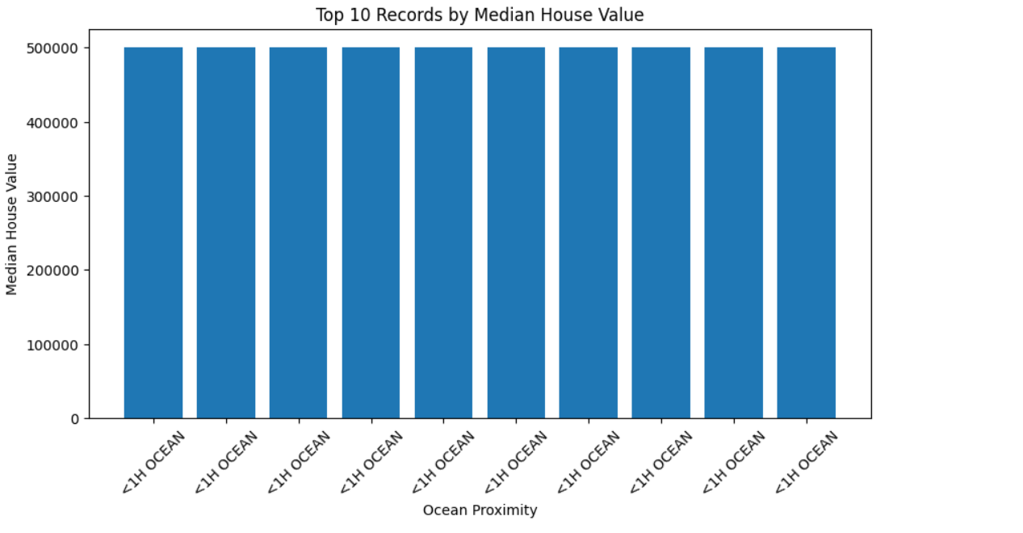

Mean Median House Value =
206855.81690891474

Median Median House Value =
179700.0

Mode Median House Value =
0 500001.0
Name: median_house_value, dtype: float64

Standard Deviation =
115395.6158744132

Minimum Median House Value =
14999.0

Maximum Median House Value =
500001.0

Descriptive Statistics
total_rooms total_bedrooms population households \
count 20640.000000 20433.000000 20640.000000 20640.000000
mean 2635.763081 537.870553 1425.476744 499.539680
std 2181.615252 421.385070 1132.462122 382.329753
min 2.000000 1.000000 3.000000 1.000000
25% 1447.750000 296.000000 787.000000 280.000000
50% 2127.000000 435.000000 1166.000000 409.000000
75% 3148.000000 647.000000 1725.000000 605.000000
max 39320.000000 6445.000000 35682.000000 6082.000000

median_income median_house_value
count 20640.000000 20640.000000
mean 3.870671 206855.816909
std 1.899822 115395.615874
min 0.499900 14999.000000
25% 2.563400 119600.000000
50% 3.534800 179700.000000
75% 4.743250 264725.000000
max 15.000100 500001.000000

Average House Value by Ocean Proximity
ocean_proximity
ISLAND 380440.000000
NEAR BAY 259212.311790
NEAR OCEAN 249433.977427
<1H OCEAN 240084.285464
INLAND 124805.392001
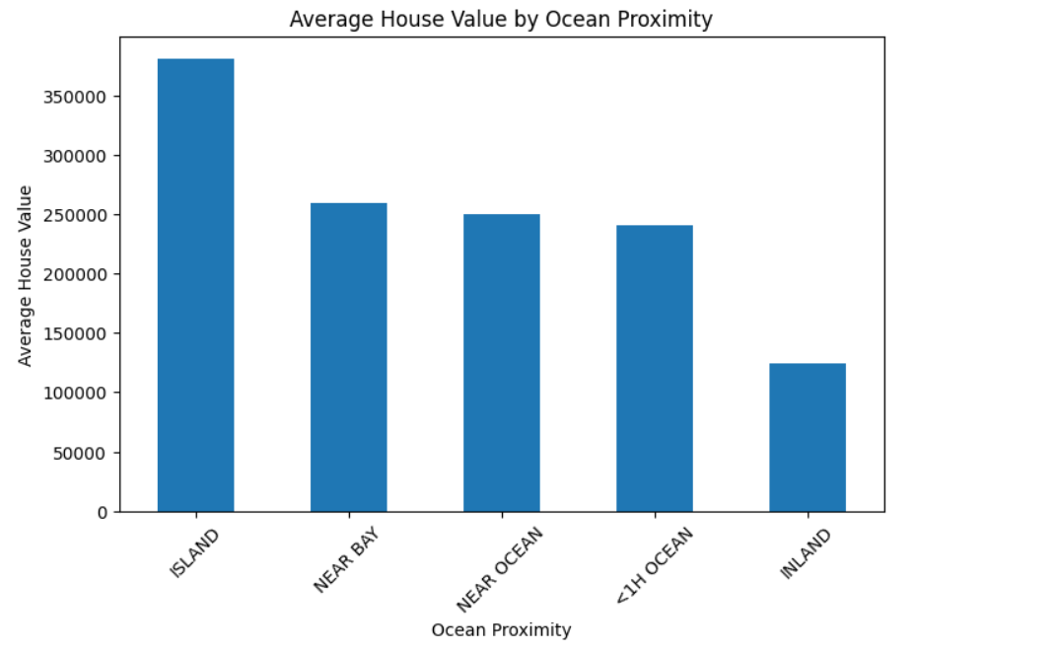
Ocean Proximity-wise Aggregation
median_house_value median_income total_rooms \
ocean_proximity
<1H OCEAN 240084.285464 4.230682 2628.343586
INLAND 124805.392001 3.208996 2717.742787
ISLAND 380440.000000 2.744420 1574.600000
NEAR BAY 259212.311790 4.172885 2493.589520
NEAR OCEAN 249433.977427 4.005785 2583.700903

total_bedrooms population households
ocean_proximity
<1H OCEAN 546.539185 1520.290499 517.744965
INLAND 533.881619 1391.046252 477.447565
ISLAND 420.400000 668.000000 276.600000
NEAR BAY 514.182819 1230.317467 488.616157
NEAR OCEAN 538.615677 1354.008653 501.244545

Correlation Matrix
longitude latitude housing_median_age total_rooms \
longitude 1.000000 -0.924664 -0.108197 0.044568
latitude -0.924664 1.000000 0.011173 -0.036100
housing_median_age -0.108197 0.011173 1.000000 -0.361262
total_rooms 0.044568 -0.036100 -0.361262 1.000000
total_bedrooms 0.069608 -0.066983 -0.320451 0.930380
population 0.099773 -0.108785 -0.296244 0.857126
households 0.055310 -0.071035 -0.302916 0.918484
median_income -0.015176 -0.079809 -0.119034 0.198050
median_house_value -0.045967 -0.144160 0.105623 0.134153

total_bedrooms population households median_income \
longitude 0.069608 0.099773 0.055310 -0.015176
latitude -0.066983 -0.108785 -0.071035 -0.079809
housing_median_age -0.320451 -0.296244 -0.302916 -0.119034
total_rooms 0.930380 0.857126 0.918484 0.198050
total_bedrooms 1.000000 0.877747 0.979728 -0.007723
population 0.877747 1.000000 0.907222 0.004834
households 0.979728 0.907222 1.000000 0.013033
median_income -0.007723 0.004834 0.013033 1.000000
median_house_value 0.049686 -0.024650 0.065843 0.688075

median_house_value
longitude -0.045967
latitude -0.144160
housing_median_age 0.105623
total_rooms 0.134153
total_bedrooms 0.049686
population -0.024650
households 0.065843
median_income 0.688075
median_house_value 1.000000
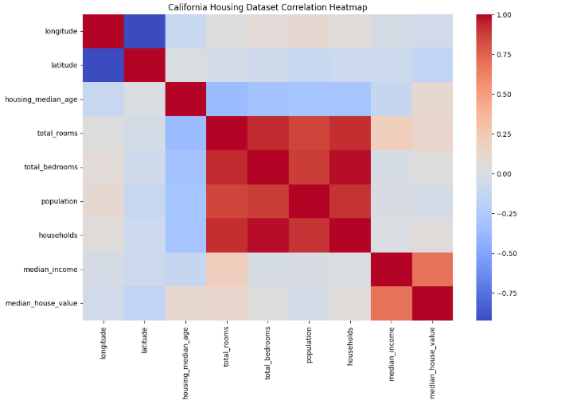
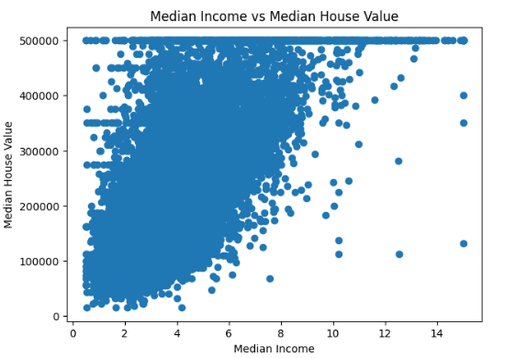
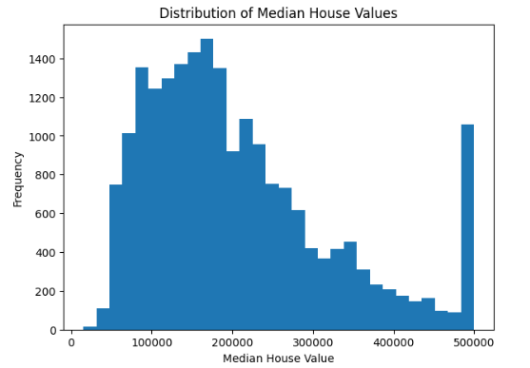
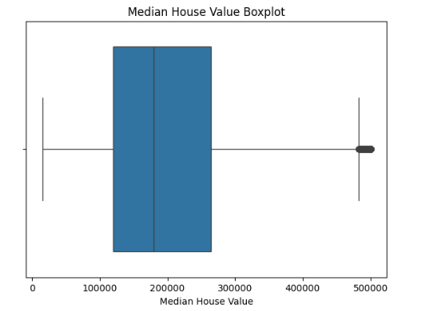

Name: count, dtype: int64

Unique Ocean Proximity Values
['NEAR BAY' '<1H OCEAN' 'INLAND' 'NEAR OCEAN' 'ISLAND']

Top 10 Records by Median Income
 | longitude | latitude | median_income | median_house_value | ocean_proximity
8851 | -118.42 | 34.09 | 15.0001 | 500001.0 | <1H OCEAN
8850 | -118.41 | 34.09 | 15.0001 | 500001.0 | <1H OCEAN
8849 | -118.40 | 34.08 | 15.0001 | 500001.0 | <1H OCEAN
8848 | -118.39 | 34.08 | 15.0001 | 500001.0 | <1H OCEAN
8852 | -118.42 | 34.08 | 15.0001 | 500001.0 | <1H OCEAN
15241 | -117.23 | 32.99 | 15.0001 | 500001.0 | NEAR OCEAN
8878 | -118.50 | 34.04 | 15.0001 | 500001.0 | <1H OCEAN
8805 | -118.34 | 33.76 | 15.0001 | 500001.0 | NEAR OCEAN
8847 | -118.40 | 34.09 | 15.0001 | 500001.0 | <1H OCEAN
16910 | -122.36 | 37.56 | 15.0001 | 500001.0 | NEAR OCEAN

Top 10 Records by Total Rooms
 | longitude | latitude | total_rooms | total_bedrooms | median_house_value | ocean_proximity
13139 | -121.44 | 38.43 | 39320.0 | 6210.0 | 153700.0 | INLAND
10309 | -117.74 | 33.89 | 37937.0 | 5471.0 | 366300.0 | <1H OCEAN
9880 | -121.79 | 36.64 | 32627.0 | 6445.0 | 118800.0 | <1H OCEAN
6057 | -117.78 | 34.03 | 32054.0 | 5290.0 | 253900.0 | <1H OCEAN
12201 | -117.20 | 33.58 | 30450.0 | 5033.0 | 174300.0 | <1H OCEAN
9019 | -118.78 | 34.16 | 30405.0 | 4093.0 | 399200.0 | NEAR OCEAN
12215 | -117.12 | 33.52 | 30401.0 | 4957.0 | 212300.0 | <1H OCEAN
922 | -121.92 | 37.53 | 28258.0 | 3864.0 | 451100.0 | <1H OCEAN
12623 | -121.53 | 38.48 | 27870.0 | 5027.0 | 212200.0 | INLAND
6066 | -117.87 | 34.04 | 27700.0 | 4179.0 | 339700.0 | <1H OCEAN

House Value by Ocean Proximity
ocean_proximity
<1H OCEAN 2.193410e+09
INLAND 8.176001e+08
NEAR OCEAN 6.629955e+08
NEAR BAY 5.935962e+08
ISLAND 1.902200e+06
Name: median_house_value, dtype: float64

Average Median Income by Ocean Proximity
ocean_proximity
<1H OCEAN 4.230682
NEAR BAY 4.172885
NEAR OCEAN 4.005785
INLAND 3.208996
ISLAND 2.744420
Name: median_income, dtype: float64

Average Total Rooms by Ocean Proximity
ocean_proximity
INLAND 2717.742787
<1H OCEAN 2628.343586
NEAR OCEAN 2583.700903
NEAR BAY 2493.589520
ISLAND 1574.600000
Name: total_rooms, dtype: float64

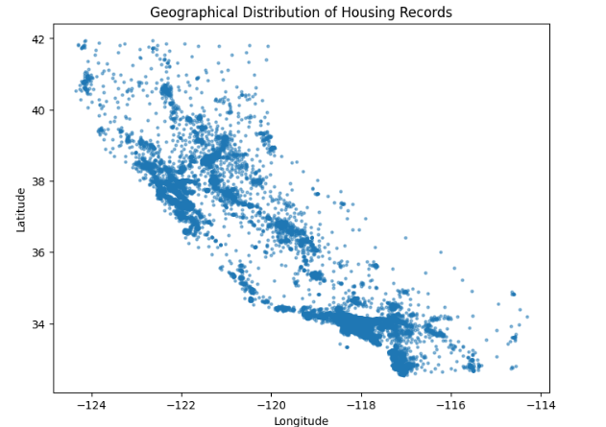
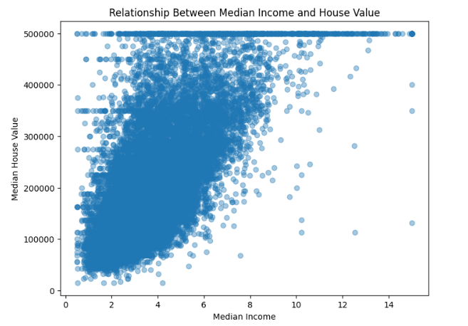
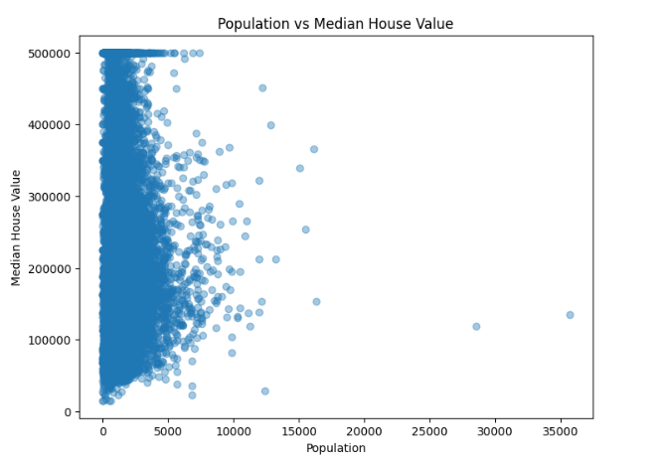
Most Common Ocean Proximity Category
ocean_proximity
<1H OCEAN 9136
Name: count, dtype: int64

==============================================
CALIFORNIA HOUSING EDA REPORT
==============================================
Dataset Shape : (20640, 10)
Total Records : 20640
Number of Ocean Proximity Categories : 5
Average Median House Value : 206855.81690891474
Minimum Median House Value : 14999.0
Maximum Median House Value : 500001.0
Average Median Income : 3.8706710029069766
Average Total Rooms : 2635.7630813953488
Average Population : 1425.4767441860465
Correlation Matrix Generated
All EDA Visualizations Generated
==============================================

EXPERIMENT COMPLETED SUCCESSFULLY

RESULT

